In this report, we are going to confirm the conclusion that in the algorithm of SHA1PRNG if we use the same seed, the random number sequence is always the same.

The related code is in test1.java
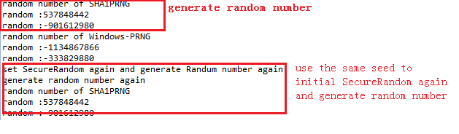
In the above figure, we can confirm our conclusion again.

And now we are going to compare the speed of different algorithm to generate same amount of random number.

The code in test2.java generates the int type random number.

The code in test4.java generates the 1024 bit random number.

Both of test2.java and test4.java may take a few minutes.

In test2.java we generate a txt file to show the average nanosecond to generate a random number

The file generated in test2.java likes this:

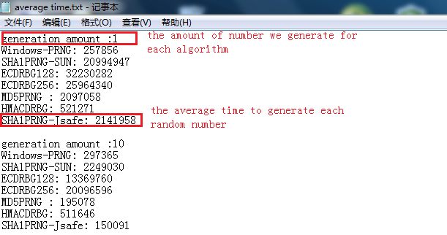
To make the data comparison more clearly, we use test4.java to generate another file and plot the figure in matlab. The generated file likes this:
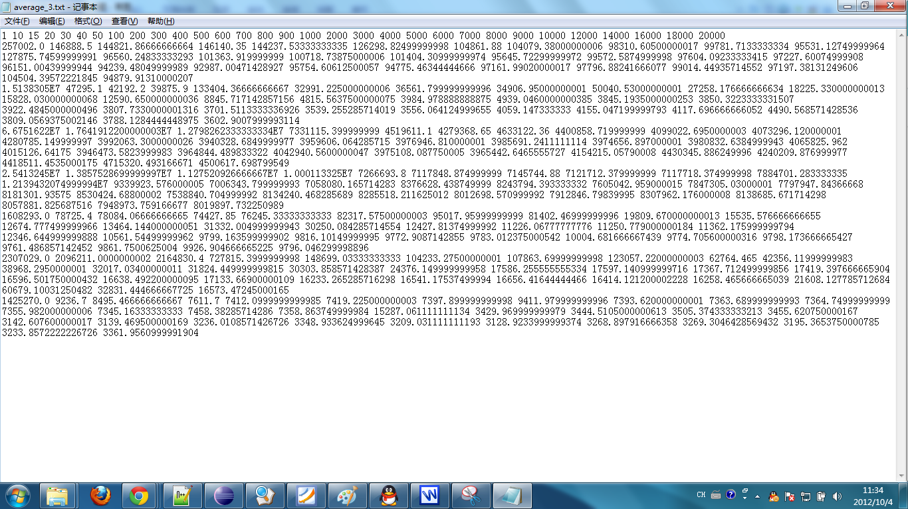
we can use matlab to import the data and use the data to draw a figure.
The process to do this likes this:

Open matlab, and click the file button
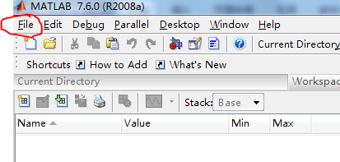

Click import data
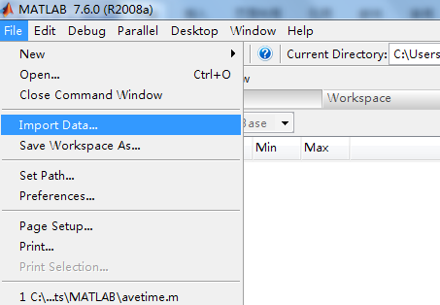

Chose the txt file we will get this
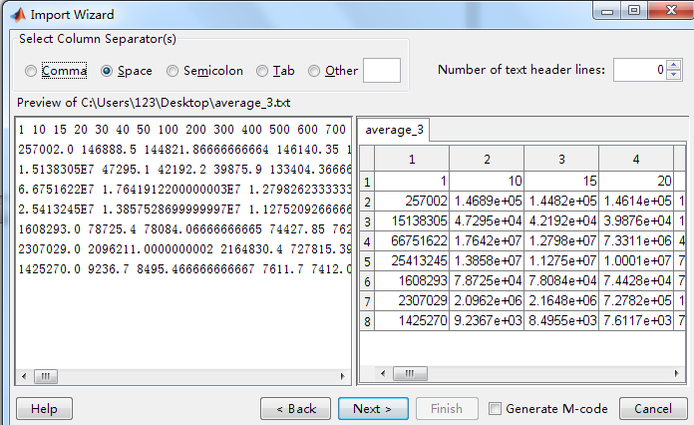
And then click next and finish. In matlab we will get a 8*31matrix
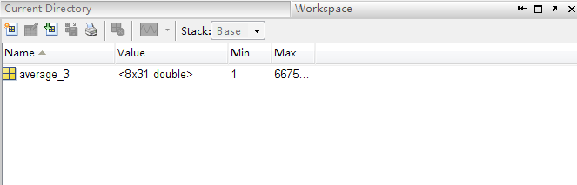

And run the matlab code to draw the figure

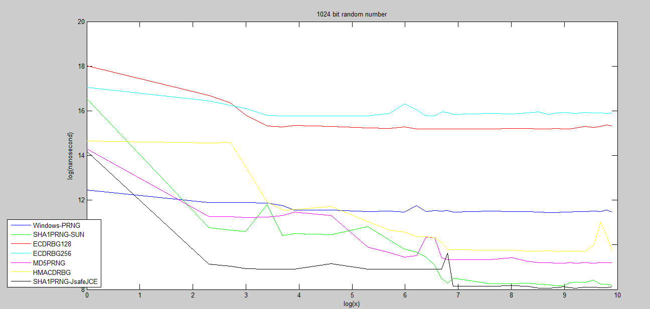

And this is the plot that generate random int number, it is also use test4.java but only change a little
